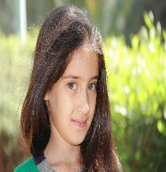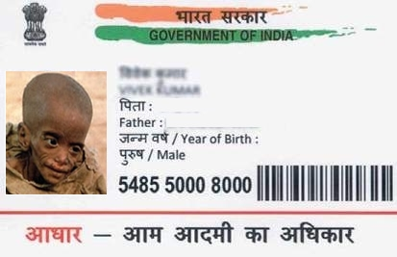

**मेरा आधार, मेरी पहचान**

**3229 2774 6273**

महिला / FEMALE

जन्म तिथि / DOB : 14/08/2007

MOHINI BHARDWAJ

मोहिनी भारद्वाज

.



[This Photo](https://www.troyhunt.com/is-indias-aadhaar-system-really-hack-proof-assessing-a-publicly-observable-security-posture/) by Unknown Author is licensed under [CC BY](https://creativecommons.org/licenses/by/3.0/)